iTrent Employee Self Service Troubleshooting User Guide

Date Created September 2021

Date Modified September 2021

Version 1.1
Contents

1. Overview 3
2. Forgotten password email link 4
3. Forgotten Username 5

- Overview

This guide is designed to assist you with account troubleshooting.

Original Login Details

Your login details would have been sent to you by the iTrent System Administrator, normally from the email address iTrent01@cantium.solutions

The link to access the site is as follows: https://ce0045li.webitrent.com/ce0045li_ess/ess/dist/#/login

We would recommend saving this to your internet favorites as any amendments to this link or accessing a link that has been found on an internet search engine will not accept your login credentials, even though it may have a similar homepage appearance.

Below you will find the login screen where you will need to enter your login credentials.

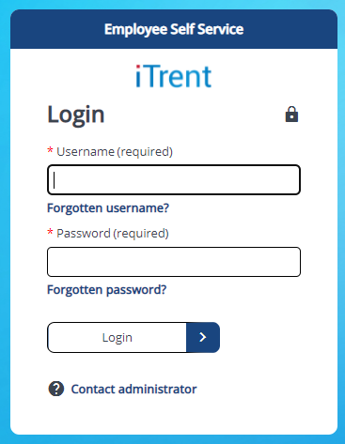

- Forgotten password email link

If you forget or want to change your password, you will need to click on the ‘forgotten password’ link.

You will be asked for your username and email address. Your email address MUST MATCH the email address that we hold for you on the system.

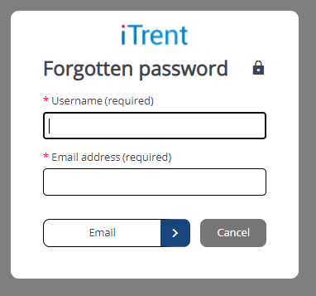

Once the details have been entered press email and a confirmation notification will appear and you will receive an email within 15 minutes.

- Forgotten Username

If you forget your username, you will need to click the ‘Forgotten username?’ link

You will be asked for your forename, surname, date of birth and email address. Your email address MUST MATCH the email address that we hold for you on the system.
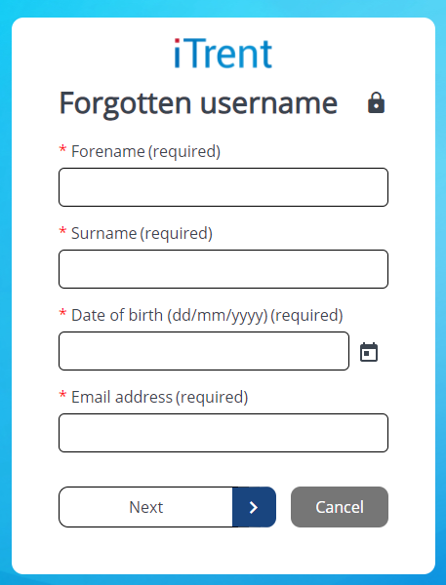

Once the details have been entered, you will receive an email within 15 minutes with your username.

