


iTrent Employee Self Service User Guide



Date Created September 2021

Date Modified September 2021

Version 1.4

Contents

1. Overview 3
Logging in 3
Forgotten password email link 5
Memorable Information 5
2.Navigating around Self‐Service 8
The homepage 8
E-Form Preferences 9
3. The Personal Tab 12
Personal Details 12
4.Pay & Benefits 13
Payslips 13
P60 14
5.Web Apps 15
ESS iOS Web App 15
ESS Android Web App 18

- Overview

This guide is designed to assist you with self-service key tasks, such as viewing payslips, P60’s and Personal Details.

Logging in

Your login details would have been sent to you by the Self-Service System Administrator, normally from the email address iTrent01@cantium.solutions.

The link to access the site is as follows: https://ce0045li.webitrent.com/ce0045li_ess/ess/dist/#/login?page=login

We would recommend saving this to your internet favorites as any amendments to this link or accessing a link that has been found on an internet search engine will not accept your login credentials, even though it may have a similar homepage appearance.

Below you will find the login screen where you will need to enter your login credentials.

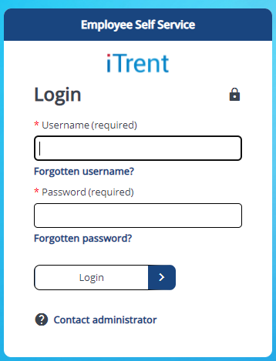

Your user name and password would have been supplied to you separately in an email and these credentials should be entered here. Your user name is not case sensitive, but your password is.

If this is the first time you have logged in, or you are changing your password via the ‘Forgotten Password link’, please bear in mind the following:

- Passwords must include both upper- and lower-case characters.

- Passwords must include both letters and numbers.

- Minimum password length is 6 characters.

- A user’s password will lock out after 8 failed log on attempts – this is when the message will read ‘Invalid Log in’.

- Once you have had 8 failed log on attempts you must then use the forgotten password link.

- Passwords are set to time out after 90 days, if you have not read the popup message that tells you to reset your password and then actually changed it, iTrent will deactivate your account. You must then use the forgotten password link to reactivate your account.

- You will have one opportunity to log in with your expired password. If you log out without changing your password, you will become ‘Inactive’ and you must then use the forgotten password link to reactivate your account.

Forgotten password email link

If you forget your password, you will need to click on the ‘forgotten password’ link.

You will be asked for your username and email address. Your email address MUST MATCH the email address that we hold for you on the system. If you are unsure as to what this email address is, we would recommend using your work email address first and then your personal email address.

To reset your password, simply click the ‘Forgotten password?’ link, and then provide the username and the email address linked to your account. An email will be sent to you within 15 minutes of the request. Once this has been received click “Reset your password”, and then change your password.

If you do not know your username, you will need to click on the ‘forgotten username’ link.

To use the forgotten username feature you must have completed your memorable information. If you have not completed this, you will need to email iTrent01@cantium.solutions and request a username reminder. Please see how to set memorable information up on Page 6 for future reference.

If you already have this feature set up, simply click the forgotten username link and enter your Forename, Surname, Date of birth and email address. You will then be given your memorable information prompt. Once you have entered this your username will pre‐populate.

Memorable Information

Once you login, you must complete your memorable information in order to retrieve your user name and should you forget this in the future. To do this go to;

Utility Menu (top right corner) > Settings > Memorable Information

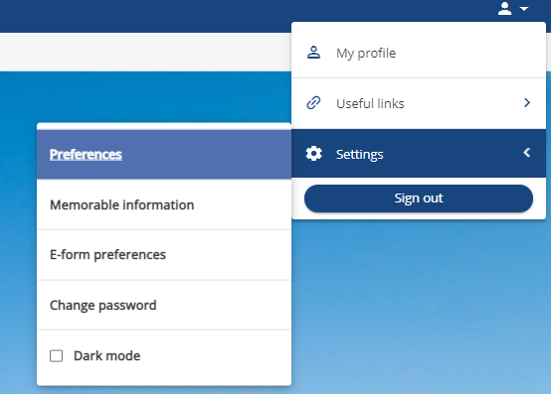
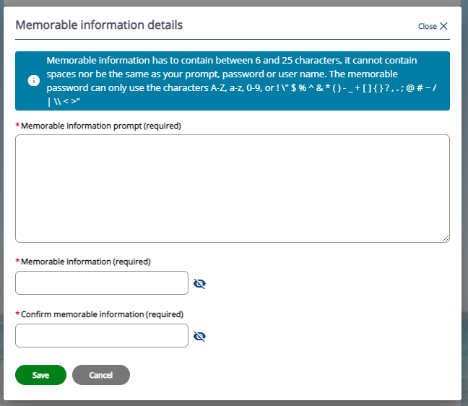

The prompt for your memorable information can be whatever you like, as long as it reminds you what the memorable information actually is. Some example prompts could be:

- What’s your mother’s maiden name?

- What was the name of primary school?

- What was the make of your first car?

The memorable information response has to contain between 6 and 25 characters, it cannot contain spaces and it cannot be the same as your prompt, password or user name.

- Navigating around Self-Service

The homepage

When you first login to ESS you will be presented with your personal home page, as pictured below. From here you can access all the functionality and data granted to your user profile.
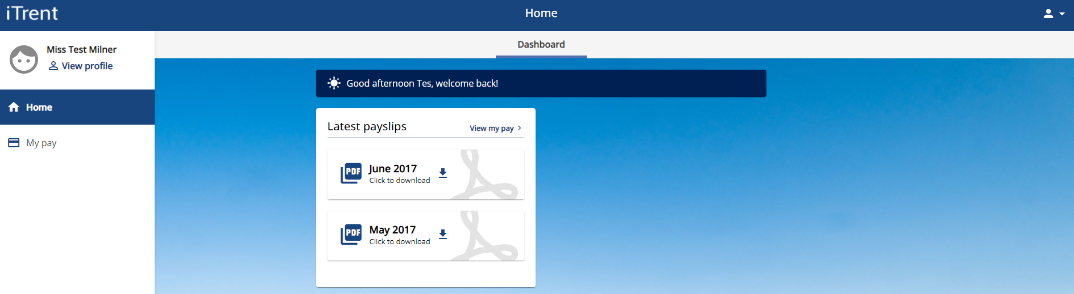
(3)
(2)
(1)

- The home button

The Home button can be used to return to the home page from any part of the system.

- The tabs

When you select a tab you will be taken to a summary page, which is broken down into sections and summary cards. The sections represent the categories of data within each area, for example under the My Pay tab there are sectopns for Payslips and P60s.

- The Profile button

The Profile button remains present throughout ESS and gives you access to global controls, such as your Personal and Employment details, setting your memorable information, e-preferences.

E-Form Preferences

This is where you can choose to have your P60 and payslips emailed monthly directly to you.

To do this go to Settings > E-form preferences

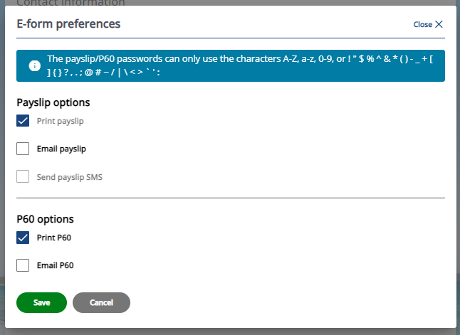

The below three fields will appear for completion once you tick ‘Email payslip’

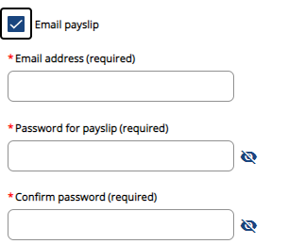

Once you have entered your email address and password tick the below fields to automatically copy the info for your P60 options.

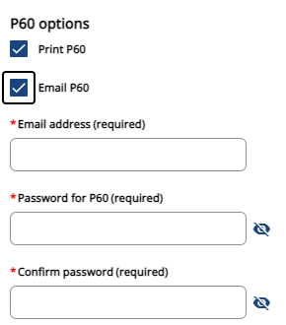

- The Personal Tab

Personal Details

The first tab under My Profile is the ‘Personal’ tab. If you select this tab you will be able to view your basic personal info such as your name and date of birth as well as your current contact information, bank details etc.

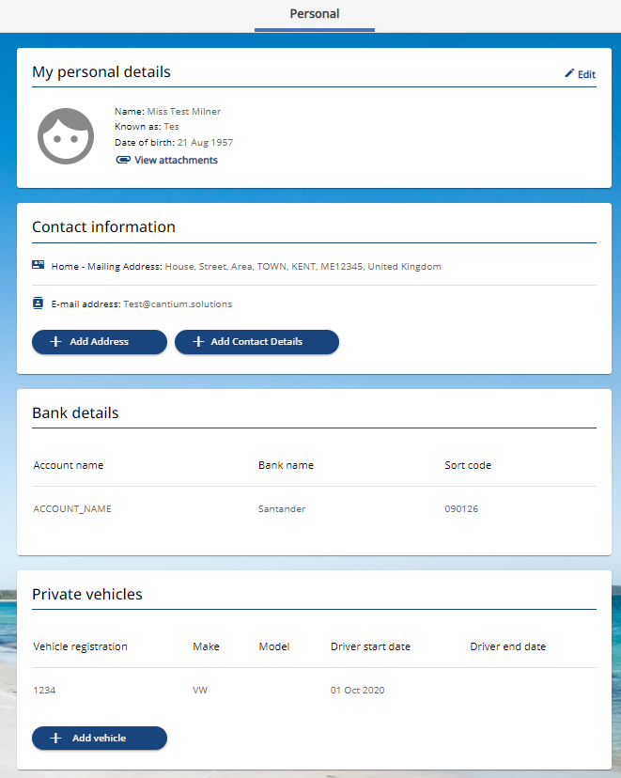

- Pay & Benefits

Payslips

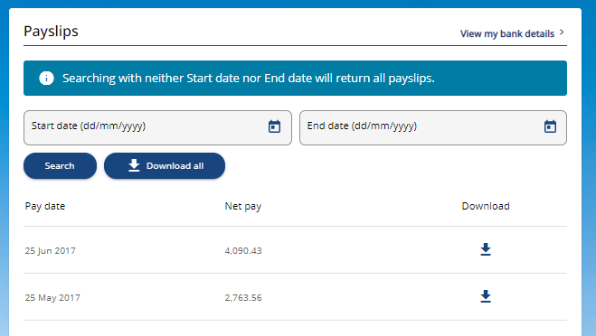

By clicking on a relevant month this will produce an onscreen snapshot of your months’ pay. Once this has opened you can choose to download this as a PDF by selecting ‘Download’ in the top right hand corner of the payslip summary, this will give you a more detailed breakdown of your month’s pay.

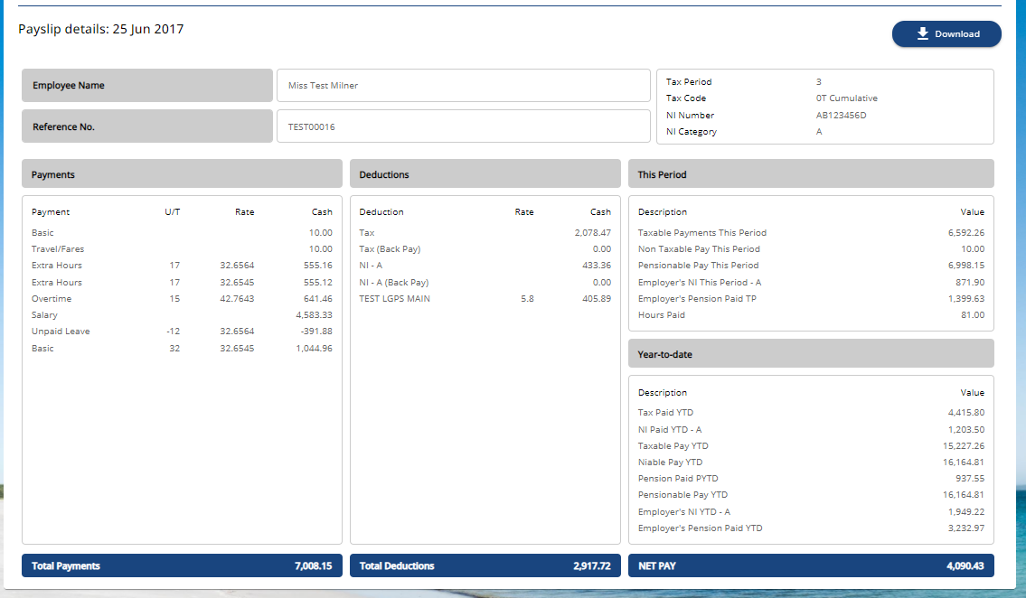

If you have been employed longer than one month, your previous payslips will display a history for you to view along with any P60’s.

The payslips pane will show the last 12 Months’ payslips, if you require one that is outside of this timeframe, enter the date(s) you wish to download and press ‘Search’

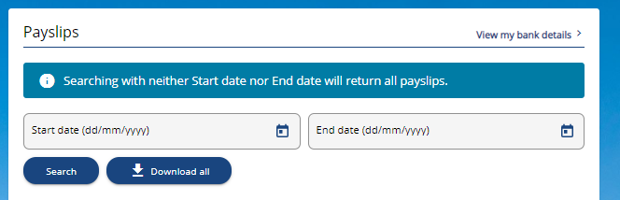

From there, click on the relevant result to view or download the payslip.

Please note we only hold payslips for the period that you have been an employee on iTrent. If you require a payslip before this time, please contact your HR Department directly to find out how to receive this.

P60

To view your P60, select the P60 you require by pressing the download button to the right;

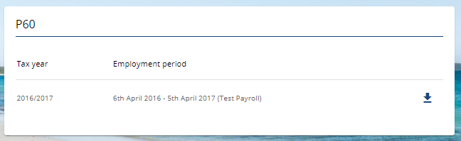

Please note, if you have been an employee on iTrent for a short period of time, you may not be able to view your previous year’s P60. Please contact your school to find out how to get this. Any future P60’s will be viewable here.

- Web Apps

ESS iOS Web App

ESS can be accessed on iOS devices via a web app:

Enter the iTrent ESS URL into the Safari browser

Click on the Share icon 

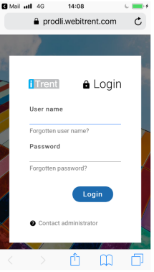

Add to Home Screen

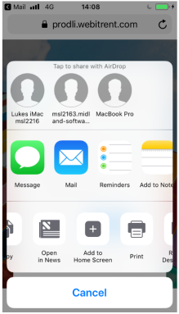

Change the name of the web app (if desired) and select Add

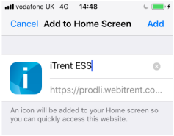

iTrent ESS will then display as an app on your iOS mobile device.

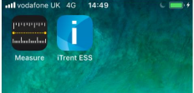

ESS Android Web App

ESS can be accessed on Android devices via a web app:

Enter the iTrent ESS URL into the Chrome for android browser app
Tap on for menu options

Select the Add to Home Screen option from the list

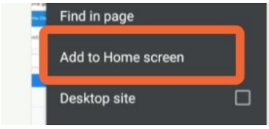

Tap on the Add command and touch and hold to place manually OR select the Add Automatically command

The Shortcut link will be created on the Home screen of your Android phone
‐‐‐‐‐‐‐‐‐‐‐‐‐‐‐‐‐‐‐‐‐‐‐‐‐‐‐‐‐‐‐‐‐‐‐‐‐‐‐‐‐‐‐‐
If you require any support with the functions in this guide, you can contact the Self-Service Support
Team at iTrent01@cantium.solutions

