Receive your payslips by email

E-Form Preferences

This is where you can choose to have your P60 and payslips emailed monthly directly to you.

To do this go to Settings > E-form preferences

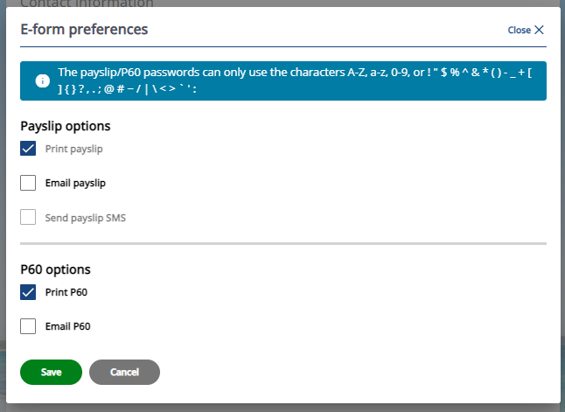

The below three fields will appear for completion once you tick ‘Email payslip’

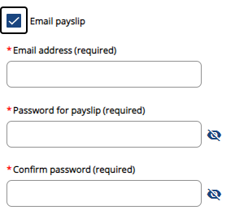

Once you have entered your email address and password tick the below fields to automatically copy the info for your P60 options.

